Analysis Documentation

Contents

Background 1 2

The problem 2

The client 2

Investigation of analysis of the current design 5 3

Interviewed 3

Teacher 3

Parent 3

Student 3

Sent questionnaires 3

results 4

Observed 5

Observation of a teacher’s appointment sheet 5

Observation of a parents evening 5

Analysed 5

Limitations 6

Problem definition 2 7

Aims 7

limitations 7

Objectives 2 9

# Background 1

## The problem

Wakemen college holds parents evening in which parents will come into college to talk to their child’s teachers. Currently this is done by the students filling in their names into an open space in a teacher’s appointment sheet on a first come first come first served basis. The problem is that this is very inefficient and leaves a lot of parents unable to see teachers. The project was chosen due to the fact that the number of people not getting appointments and therefore not turning up was considered unacceptable by the member of staff organising the parent’s evenings.

## The client

The organisation that I am undertaking this project for is a state sixth form college and it is situated in Shrewsbury. The volume of use will not be great as parents evenings are scheduled twice a year.

# Investigation of analysis of the current design 5

To gather information on the current system and to analyse it I:

Interviewed a teacher, a parent, a student and the person who is currently in charge of organising parents evenings

### Teacher

The teacher said that she felt that there was a large problem with students turning up late to her appointments, to usual excuse was that they had had to rush due to booking appointments too close together. She also had a problem with many of the students whose parents she wanted to talk to didn’t get appointments with weak excuses. She went on to say that she felt that the problems listed above would be solved by appointments being assigned.

### Parent

The parent said that the parents evenings were badly put together as his children who were in the same year had a great difficulty getting appointments due to just his children having problems getting them and that they did at times get appointments for the same slot as each other due to the small window of time to book and the lack of communication between the two and would prefer it if the appointments were assigned and took into account the fact that there may be more than one child from each family in the year. The parent also felt that there was too much waiting for appointments due to people turning up late.

### Student

The student gave the impression that he felt that parents evenings are currently poorly organised, he felt that it was difficult to get the times he wants. Though he books his appointments at least 5 minutes apart he felt that too many did not do so and it “corrupts the system and causes disarray”, Jonathan Mortiboy, and believes that any preventative measure would be welcome. He finished the interview saying that the current system was deeply flawed and needed to be changed quickly as it has been left in its current poor state for too long.

Person in charge of organising parents evenings

Sent questionnaires to a larger number of students, teachers and parents so as to get a larger amount of input so as to tailor the system to please the majority of users.

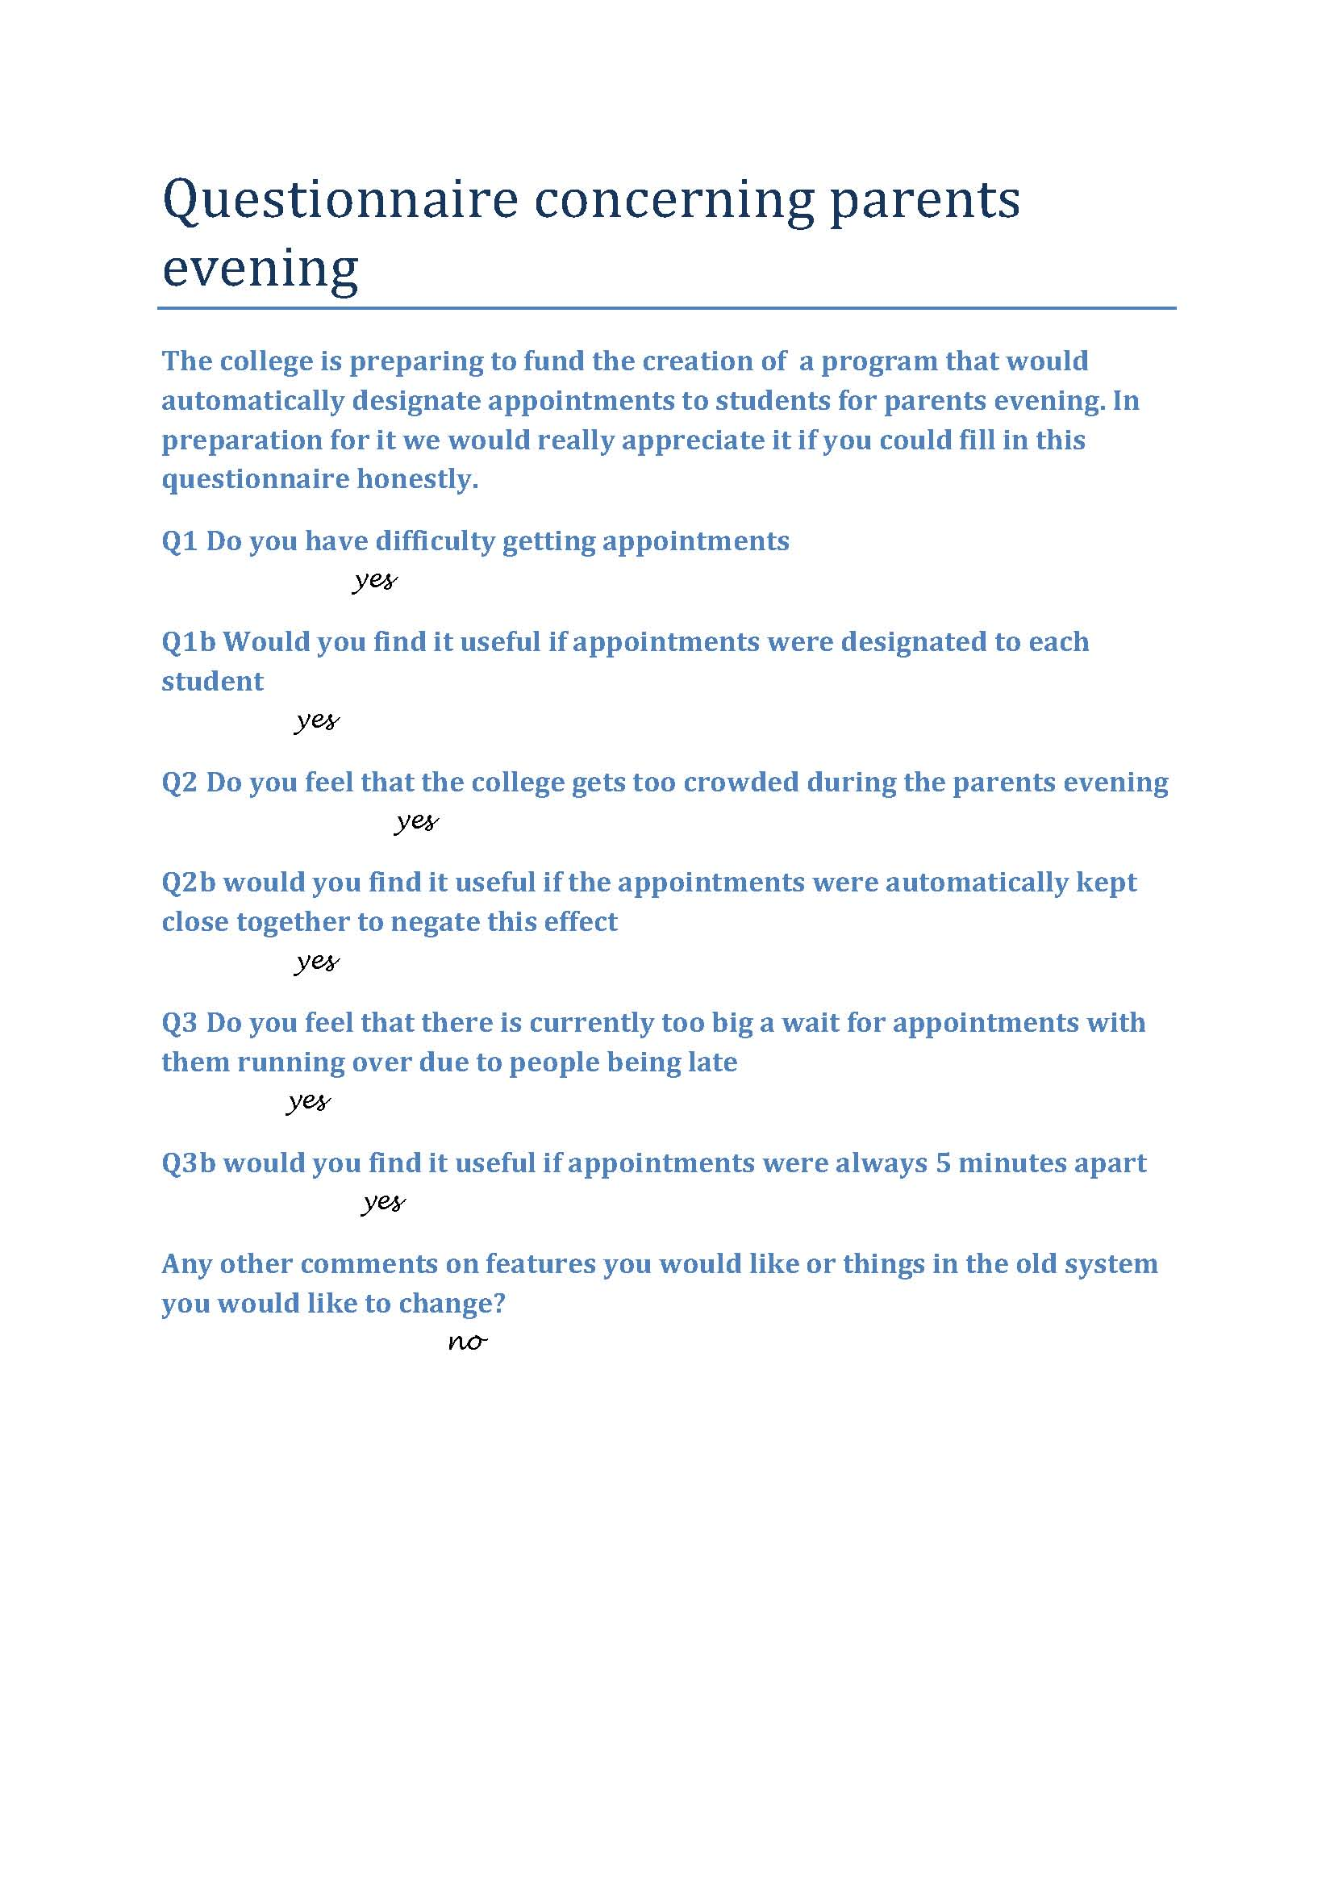

### results

The results were that in a sample size 352 people who returned the questionnaire

198 or 56% said that they had problems getting appointments

304 or 86% felt that it would be good if the appointments were designated to each person

261 or 74% felt that the college gets too crowded during parent’s evening

215 or 61% felt that it would be solved by making sure that appointments were close together

314 or 89% felt that the wait for appointments was too big due to people being late

338 or 96% felt that it should be mandatory for appointments to me no less than 5 minutes apart

Other comments contained ideas such as they would like to have in acceable via the internet, they would like a map generated and that they would like to be able to be able to change their requested time slot at any time in the run up to the parents evening.

Observed a teachers appointment sheet during the appointment gather process and a parents evening

### Observation of a teacher’s appointment sheet

The appointment sheet fills quite quickly as the teacher offers it to the students in their lessons in the order he or she sees them. After the first class has been through sheet is covered with a scattered group names and by the 3rd class there is a significant number of students unable to get times that would be suitable and end up settling for times that are not in proximity or just deciding not to attend.

#### Summation

Appointments are given our on first come first served basis that benefits heavily the students that have a teacher first

This leads to many getting times that do not fit with others or students not attending

And due to lack of coordination and not knowing what times they could get students may have taken a time slot that they could have got in a different lesson and thereby miss out on an appointment time

### Observation of a parents evening

The building was filled with many parents and students that filled up all the corridors and all spare space in the college creating a crowded atmosphere. And a lot of waiting due to people being late in some cases and people taking too long in an appointment in others.

#### Summation

The school was crowded due to the length of time people appointments were spread out under

There was a lot of queuing due to people being late for appointments by booking them too close together.

Analysed the existing documentation

The existing documentation consists solely of teacher’s appointment sheets and students appointment sheets.

The teachers sheet is an A4 sheet with a simple table with 4 columns the first and third contain appointment times and the second and fourth are empty, ready for students to put their name in to book the appointment. It is easy to understand the student just fills his name into an empty slot; the simplicity allows a teacher to let the students book appointments without constant observation. The lack of supervision dose however allow for a student to change the information. Another problem is that it is one fragile piece of paper that contains the appointments which means that it is easy to lose or break thus erasing the appointments forcing people to reapply. Another problem is that people tend to write in pen so if an appointment is removed or changed you end up with a lot of crossing out on the paper which can lead to difficulties in understanding who has what appointment. Another problem is that the form is filled out by one person at a time so there is no easy way of managing appointment swaps for those who might need one due to availability.

The student form consists of an A5 sheet of paper with 2 columns one for the name of the teacher they are seeing, the other for the time. Again this could be easily lost and gets very messy which prompts the majority of students to write their times in there planner instead making it a redundant form, ergo a waist of paper.

## Limitations

Security is poor, there is little stopping a student editing a teachers time sheet.

The system is not fair as it is first come first served so favours those who will see the teacher first.

Lack of organisation in appointments leads people to booking consecutive times causing delays.

Teachers reserve time for students they want to see disadvantaging those whose parents don’t need to see the teacher even if they have equal need to see the teacher because of higher aspirations.

The sheets are easily lost causing appointments to be lost or double booked.

Lack of communication between students does not allow for appointments to be switched around easily benefiting multiple students.

Appointments had to be made without any real idea about which ones would be available with the next teacher leading to unwantedly large gaps causing there to be more parents and students in the college than should be.

|  |
| --- |
| Students name time preferred  **Student**  Teachers appointment form  Students appointment form |

# Problem definition 2

## Aims

* Must be technically feasible, e.g. within my abilities to program
* Must be in accordance to the data protection act and other legislature
* Must be able to fit in with current work practices
* Must be backed up
* Students should be able to log on an register the time slots that they can occupy
* For it to be professional
* For it to be user-friendly
* For it to be fully error proofed
* For it to take up a small amount of memory
* For it to load quickly
* For it to be secure
* For it to be able to be adaptable
* For it to be able to access data from a spread sheet
* For it to be able to be accessed by all the users via their school logons
* For it to be able to have multiple users using at the same time
* For the program to assign everyone a time
* To allow for families with more than one child to be treated as one (but not sharing appointments)
* To not double book appointments
* To not allow appointments to be within 5 mins of one another for one person
* To be completed before the deadline
* To be completed within the budget
* To be compatible with the computers used by the college
* To be connected to email to message them their time
* To be able to easily print of times
* Will have documentation written to guide user through the program

## limitations

* I am not going to make it web based
* I am not going to make it a smart phone app
* I am not going to going to make it specifically accessible to parents
* I am not going to make any part paper based
* I am not going to make it customisable by users
* Only admin can alter system
* Cannot cost more than £100
* There will only be 1 admin
* Cannot be over 20mb
* Only passwords will be encrypted
* Will not check what computer is being used to log on
* Will not have the capacity for new fields to be added
* Will not have the capacity to work on non-windows operating systems

# Objectives 2

Describe a clear set of objectives

Must be technically feasible, e.g. within my abilities to program

* Use a programing language that I have prior experience in

Must be in accordance to the data protection act and other legislature

* Register with the data commissioner
* Only use data for intended purpose
* Don’t share with others
* Only collect relevant data
* Make sure data is accurate
* Keep data only as long as necessary
* Data must be easily corrected

Must be able to fit in with current work practices

* Students will have to use the system in their own time
* Do beta testing

Must be backed up

* Save old master files in a grandfather, father, son system.
* Save transaction files as old as the grandfather master save

Students should be able to log on and register the time slots that they can occupy

* Each student will be assigned a unique logon username, their student number.

For it to be professional

* Use minimalistic colours
* Use a house style
* Not use slang

For it to be user-friendly

* Use clear terms
* Label buttons clearly
* Create user interface in a generic manner
* Put in hot keys as well as the buttons

For it to be fully error proofed

* Make sure ever input box is fully validated so only inputs in the correct form are processed.

For it to take up a small amount of memory

* Keep the total size below ____ mb

For it to load quickly

* Make system load within ____ seconds

For it to be secure

* Make sure the areas where the passwords and confidential information is save encrypted
* Require all passwords to be alphanumeric of at least 6 characters and for admin it must be 10 characters alphanumeric and involve symbols

For it to be able to be adaptable

* Make there facilities for the customisation of the forms
* Make facilities for the admin to change the quantities of days the parents evenings are to be spread over
* Make facilities for the admin to change the times that the appointments can take place in
* Make facilities for the admin to be able the duration of the appointments

For it to be able to access data from a spread sheet

* Enable the program to be able to transfer data from spread sheets of certain formats into appropriate variables

For it to be able to be accessed by all the users via their school logons

* Make it so that if a student logs on to the appointment computer it fills in their password and username

For it to be able to have multiple users using at the same time

* Only have the files where data is saved open for fractions of a second

For the program to assign everyone a time

* Make the algorithm result in every one getting a time or with it reporting that there is not enough time allocated to parents evening

To allow for families with more than one child to be treated as one (but not sharing appointments)

* Must allow the merging brothers and sisters together
* If someone logs on ask them if they are siblings with any other user with the same last name and if they want to merge

To not double book appointments

* Must not allow an appointment slot to be booked by two or more people

To not allow appointments to be within 5 mins of one another for one person

* Ensure that no one has appointments at less than 5 minutes apart to account for travel time.

To be completed before the deadline

* Make sure the project is completed before _____

To be completed within the budget

* Make sure that the project dose not cost more than _____

To be compatible with the computers used by the college

* Make sure that the program runs on the school network

To be connected to email to message them their time

* Make it so that once the program has finished setting the times it e-mails the college emails of the students with the times

To be able to easily print of times

* Make it so that with on click a user can print out their appointment times in a professional format

Will have documentation written to guide user through the program

* Compile a document showing the steps to complete certain actions